4 ReactJS-HOL-HANDS-ON-ANSWERS
We create the React application using the following command in the VS Code terminal –
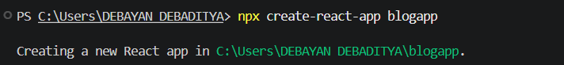
Under the ‘src’ folder “Post.js” file has been created.
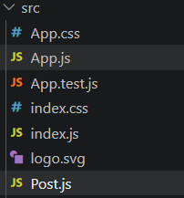
A new class based component named as Posts inside Posts.js file has been created –
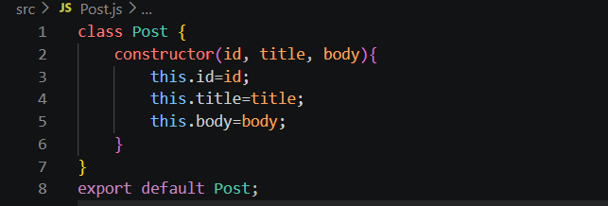
A new class based component named as Posts inside Posts.js file has been created

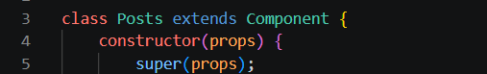

Then we add all the following required components and update the code as follows –
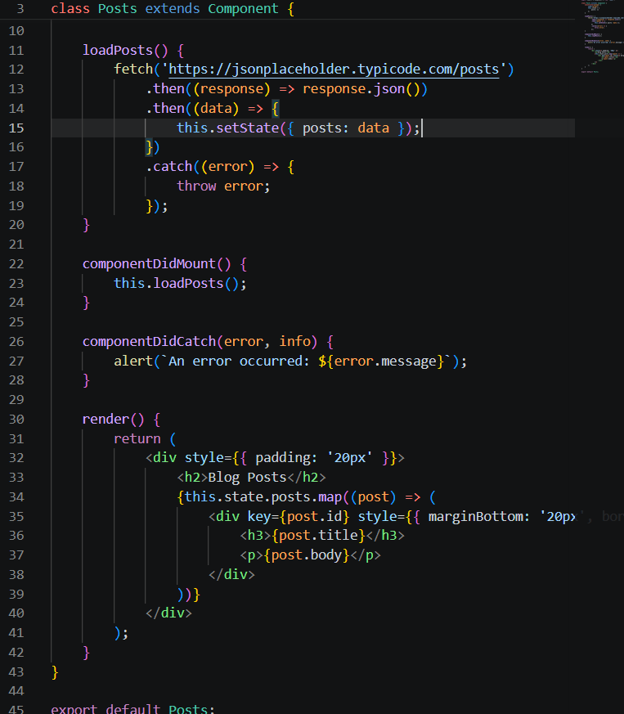

And lastly the “App.js” has been updated as –
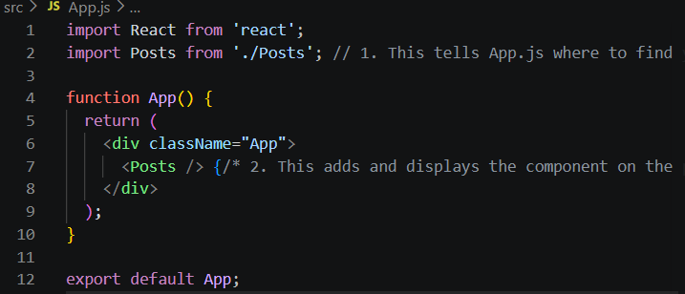

And the result is shown here –
